Passing RADIUS attribute from Cisco ISE to Comware switch

**Labels: HPE Comware Switch**

**Requirement:**

ACL 3002 and its rules are defined in switch. Same ACL number need to be passed to switch from Cisco ISE.

**Solution:**

Pass the correct RADIUS attribute from Cisco ISE,so that switch recognizes and accepts it.

Solution only shows RADIUS attribute passed from ISE server.

**Configuration:**

Vendor is **H3C**

Attribute Name is **H3C-AVPair**

Attribute ID is **210**

Attribute Value pair is **url-redirect-acl=3002**

[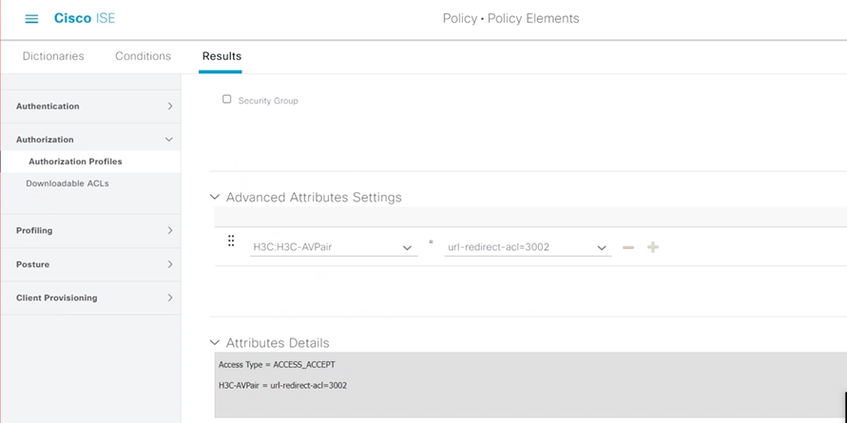](https://akb.arubanetworks.com/media/ckuploads/1110/2022/04/30/acl-attribute-being-passed-from-ise.PNG)

**Verification:**

After passing the correct AV-Pair, we should see that the ACL is now authorized by switch.

From this output, observe that vlan 114 is also passed by Radius Server (Cisco ISE).

[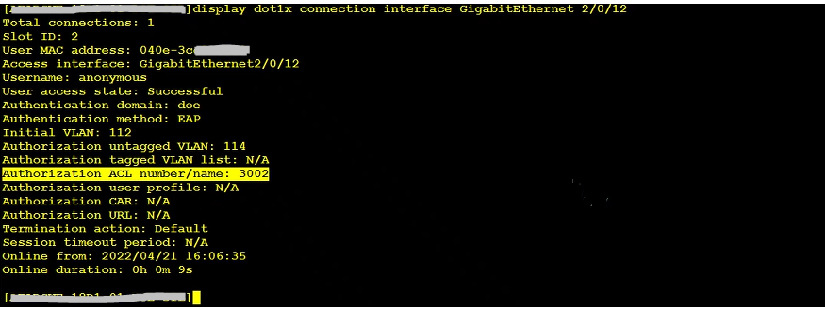](https://akb.arubanetworks.com/media/ckuploads/1110/2022/04/30/passed-acl-3002-to-comware-switch-from-ise_4ixaMCo.PNG)

Tags: HPE Comware Switch, 10.01.0040, cisco ise, comware 7, radius attribute, #acl, dynamic authorization